**HOME AUTOMATION USING**

**using**

**AVR ATMEGA32**

**Table of contents:**

**Problem statement**

**Problem solution**

**Block diagram**

**Flow chart**

**Hardware Description**

**Software Description**

**Results**

**Future scope**

**Conclusion**

**reference**

**Problem Statement**

Electrical appliances used in homes are usually controlled manually. Sometimes this may lead to wastage of power when appliances are left switched on when no one is present. So there is a need of an automatic system to detect the human presence and turn on the appliance only when necessary.

**Problem Solution**

Home automation refers to the automatic control of various home systems and appliances using sensors or IoT without manual operation. This project interfaces IR sensor and temperature sensor with AVR atmega32 microcontroller. Not only it eliminates manual operation but also it reduces power consumption by turning off the appliances when human presence is not detected.

**IR Sensor working:**

IR sensor is an electronic device, that emits light to sense some object of the surroundings. The emitter is simply an IR LED (Light Emitting Diode) and the detector is simply an IR photodiode. Photodiode is sensitive to IR light of the same wavelength which is emitted by the IR LED. When IR light falls on the photodiode, the resistances and the output voltages will change in proportion to the magnitude of the IR light received.

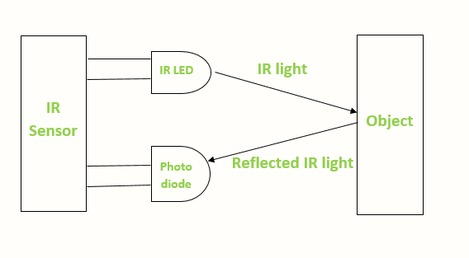

**Temperature Sensor working (lm35):**

LM35 is a temperature sensor that outputs an analog signal which is proportional to the instantaneous temperature. The output voltage can easily be interpreted to obtain a temperature reading in Celsius. The advantage of lm35 over thermistor is it does not require any external calibration.

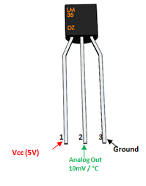

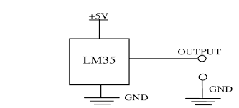

**Block Diagram**

**Flow Chart**

**Hardware description (Proteus)**

The temperature sensor and IR sensor are connected to pin A0 and A1 of PORTA respectively.

LCD data pins from D0 to D7 are connected to PORTD. The RS, R/W, and Enable pins are connected to first three pins of PORTC.

LED and Motor is connected to first two pins of PORTB.

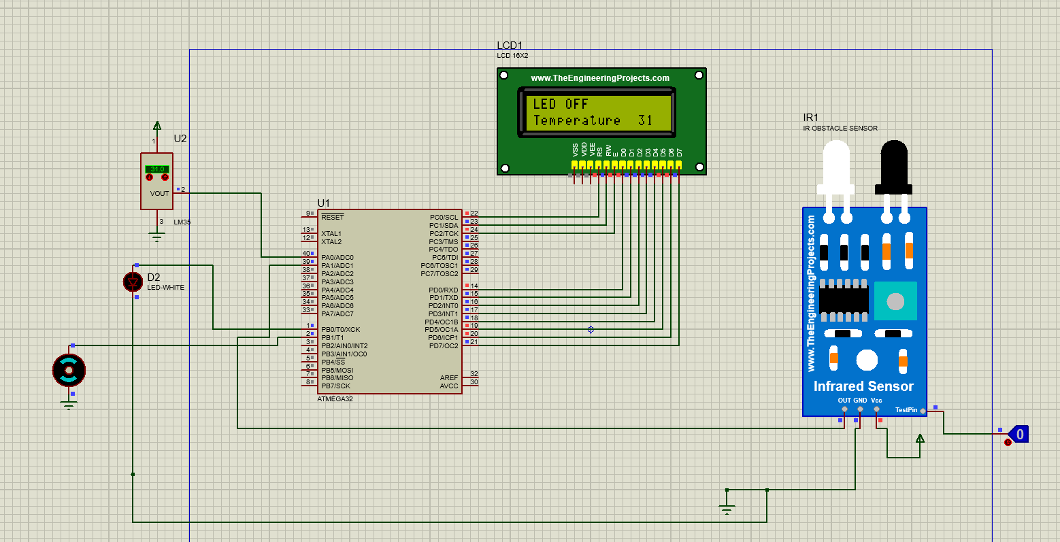

When no object is detected, both the LED and motor in OFF condition.

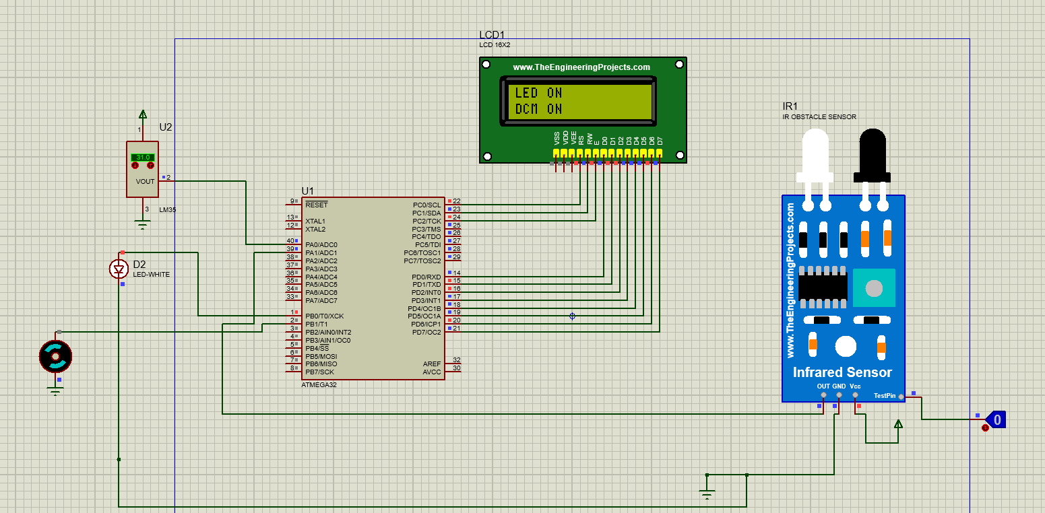

When toggle switch is clicked to show the presence of an object, and temperature is above 30 degrees, both the LED and motor will be ON. LCD displays LED ON and DCM ON.

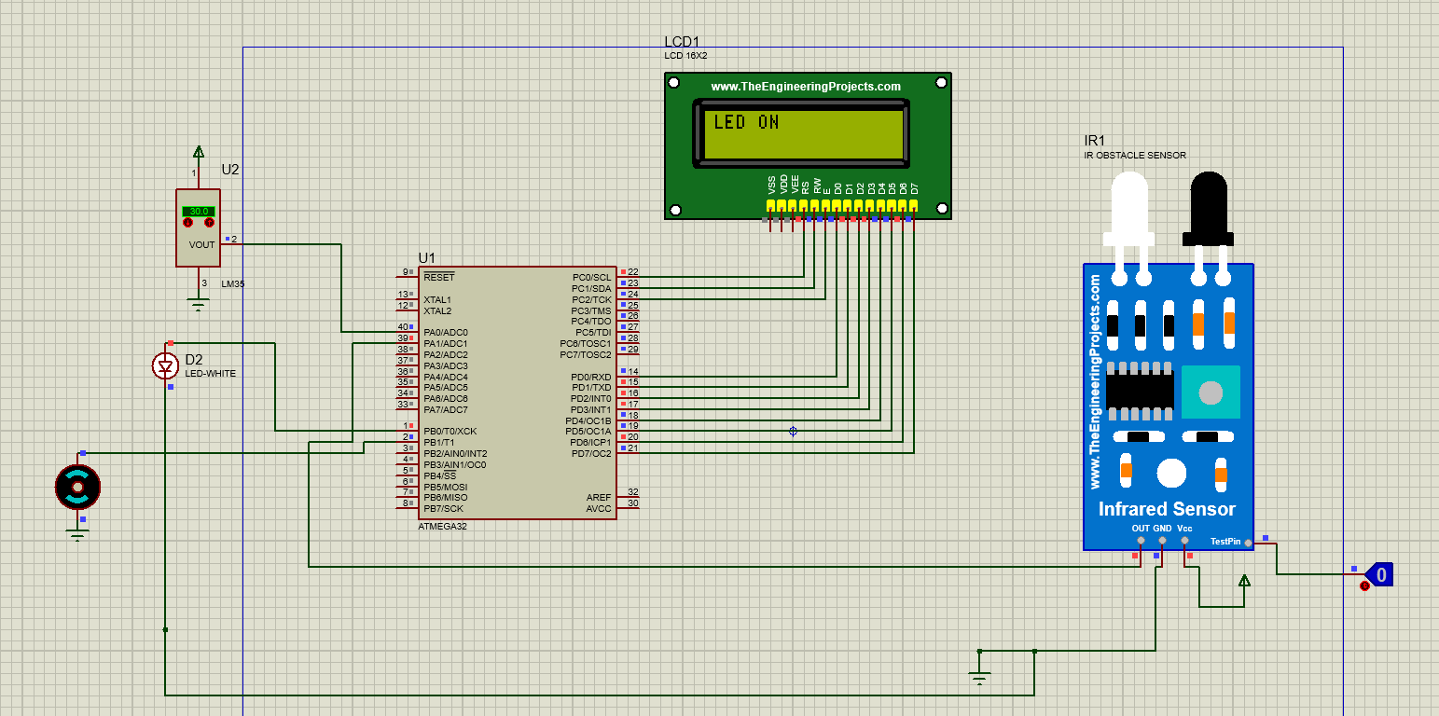

scanned.

When the temperature is below 30 degrees, but an object is present, then only the LED is ON. DC motor is OFF.

**Software description**

#include <avr/io.h>

#define *F_CPU* 16000000UL

#include <util/delay.h>

#define LCD PORTD

#define EN 2

#define RW 1

#define RS 0

void lcdcmd(unsigned char cm)

{

PORTC &=~(1<<RS); //RS = 0 - command

PORTC &=~(1<<RW); //RW = 0 - write to lcd

PORTC|=(1<<EN); //high to low pulse is given to en - to latch data

LCD=cm;

*_delay_ms*(1);

PORTC &=~(1<<EN);

}

void lcddata(unsigned char dat)

{

PORTC |=(1<<RS); //RS = 1 - data

PORTC&=~(1<<RW); //RW = 0 - write to lcd

PORTC|=(1<<EN); //high to low pulse is given to en - to latch data

LCD=dat;

*_delay_ms*(1);

PORTC &=~(1<<EN);

}

void init() {

DDRC=0XFF; //o/p - connected to lcd

DDRD=0XFF; //o/p - transfer data or cmds to lcd

lcdcmd(0X38); //8 BIT 2 LINES

lcdcmd(0X0C); //DISPLAY ON CURSOR ON

//lcdcmd(0X01); //clear screen

lcdcmd(0X80); //ROW 0 COLUMN 0

*_delay_ms*(1);

}

//fn to display string

void lcdprint(char *str){

unsigned char i=0;

while(str[i]!=0){

lcddata(str[i]);

i++;

}

}

//bcd to ascii conversion

void convert(unsigned char val){

unsigned char x,d1,d2;

x=val/10;

d1=x; // d1 = val & 0x0F

d2=val%10; //d2 = val & 0xF0

lcdcmd(0xCD);

lcddata(d1+0x30); //d1 | 0x30

lcddata(d2+0x30); //d2 | 0x30

}

int main(void)

{

DDRA &= 0b11111100; //i/p A0 - temperature sensor and A1 - ir sensor

DDRB |= 0b00000011; //o/p LED and motor

unsigned char x;

unsigned char data;

ADCSRA = 0x87; // 1000 0111

ADMUX = 0xE0; //2.56 V 1110 0000

while (1)

{

init();

lcdprint("LED OFF");

lcdcmd(0xC0);

lcdprint("Temperature");

x = PINA; //read sensor i/p for ir sensor (digital)

ADCSRA |= (1<<ADSC); //set ADSC = 1

while((ADCSRA&(1<<ADIF))==0); //when ADIF = 0, do nothing...stay in the loop.

data = ADCH;

convert(data);

//if IR o/p = 1

if(x & 0b00000010)

{

//when obstacle detected: PC.3 is 1

//ON the led

PORTB |= 0b00000001;

lcdcmd(0x01);

lcdprint("LED ON");

//temp > 30

if(data>30){

PORTB |= 0b00000010;

lcdcmd(0xC0);

lcdprint("DCM ON");

}

*_delay_ms*(70);

}

else{

//OFF led and motor

PORTB &= 0x00;

}

}

return 0;

}

**Results**

1. **Efficiency:**

Home automation systems can significantly increase the efficiency of managing various home devices and reduce energy usage.

1. **Convenience:**

They provide the convenience of controlling multiple home devices from a centralized interface.

1. **Security:**

Home automation can also include home security features like alarm systems and surveillance cameras, enhancing the safety of your home.

1. **Customization:**

These systems can be customized to the specific needs and preferences of the user.

**Future Scope**

* India's homes are poised for a remarkable transformation, as home automation technologies transcend mere convenience and usher in a new dimension of personalized comfort, unparalleled security, and conscious energy consumption.
* With rising energy costs and environmental concerns, energy-efficient smart homes are the need of the hour. Automated climate control systems, smart lighting, and energy monitoring are trends that resonate well with the eco-conscious Indian consumer.
* The integration of AI and voice assistants like Amazon Alexa and Google Assistant is revolutionizing home automation. Voice-controlled devices are expected to become more sophisticated, understanding and predicting user preferences for a more personalized experience.
* The Internet of Things (IoT) is at the heart of home automation. The future will see more interconnected devices, offering seamless control over the entire household ecosystem from a single interface.

**Conclusion**

**Positive Impact:**

The advent of home automation has made a positive impact on our lifestyles, transforming the way we live and interact with our home environment.

**Future Potential:**

With the rapid advancement of technology, the potential for more sophisticated and integrated home automation solutions is vast.

**Challenges:**

Despite the advantages, there are also challenges to be addressed, such as ensuring the security and privacy of connected devices.

**Adoption Rate:**

As smart home technology becomes more affordable and user-friendly, more households are expected to adopt it, making it a significant trend in the future of residential living.

In conclusion, home automation systems offer a range of benefits, including convenience, efficiency, and enhanced security. However, like any technology, they come with their own set of challenges that need to be addressed for wider adoption. As technology continues to advance, we can expect to see even more sophisticated home automation solutions in the future.

**References**

* <https://www.linkedin.com/pulse/exploring-future-home-automation-trends-india-phynart-gqa3f/>
* <https://byretreat.com/what-is-the-conclusion-of-smart-home-automation/>
* <https://link.springer.com/chapter/10.1007/978-981-99-0838-7_14>